Civil war in Liberia

UNSC Resolution: | 1343
Date of adoption: | 7-Mar-2001
Operative paragraph: | 15
Demand number: | 1343,1511

Sarah-Myriam Martin-Brûlé

Wording of demand

establish an effective Certificate of Origin regime for trade in rough diamonds that is transparent and internationally verifiable and has been approved by the Committee established by paragraph 14 above, to come into operation after the measures imposed by paragraphs 5 to 7 above have been terminated in accordance with this resolution

List of addressees of the demand

Government of Liberia

Short-term compliance

Description of the addressee(s)’ conduct

“10. The United Nations Office in Liberia was informed that, on 16 March 2001, a ban had been placed on the entry of all uncertified rough diamonds from countries with existing certification regimes. On 19 March 2001, the Government of Liberia unilaterally closed its border with Sierra Leone and announced that it had since arrested seven diamond smugglers. The export of Liberia’s own rough diamonds was also banned for a period of 120 days, pending the establishment of an internationally acceptable certification regime in Liberia. The Government contends that the second measure goes beyond the demands of the Security Council. On 21 March 2001, President Taylor wrote to the Secretary-General (S/2001/264) requesting the assistance of the United Nations. The Government of Liberia has also requested technical assistance from the High Diamond Council.”
United Nations Security Council, First report of the Secretary-General pursuant to Security Council resolution 1343 (2001) regarding Liberia. 30 April 2001

Assessment

Short-term compliance
No or marginal compliance (1) | Medium low compliance (2) | X Medium high compliance (3) | Full or almost full compliance (4)

Considerations underlying the assessment

Within the six months following the adoption of the demand, the government made significant efforts to establish an effective Certificate of Origin regime for trade in rough diamonds that is transparent and internationally verifiable and has been approved by the Committee established by paragraph 14 above, to come into operation after the measures imposed by paragraphs 5 to 7 above have been terminated in accordance with this resolution.

Medium-term compliance

Description of the addressee(s)’ conduct

“24. The Government of Liberia has tried to comply with the Security Council resolution on the issue of a certificate of origin for rough diamonds. The Government alleges that its efforts have been stalled by some powerful interests in the Security Council. Consequently, the Government has not been able to establish a certificate of origin. However, Liberia has continued to participate in the Kimberly Process and efforts are ongoing to reach agreement on the certificate of origin.”
United Nations Security Council. First report of the Secretary-General pursuant to Security Council resolution 1408 (2002) regarding Liberia 22 October 2002

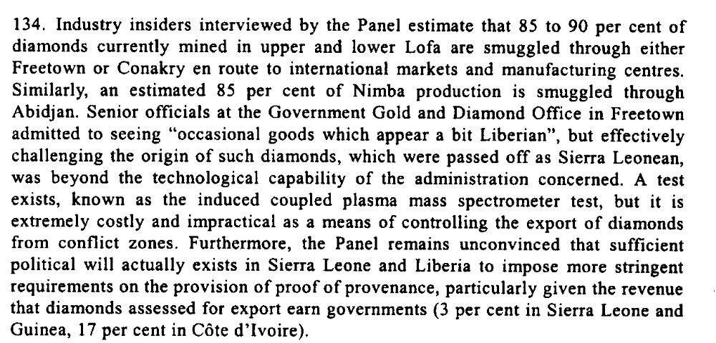
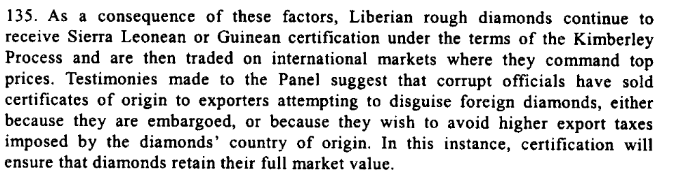
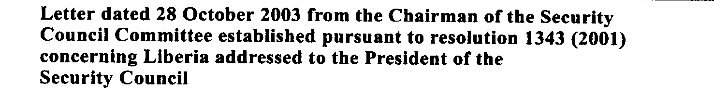

Assessment

Medium-term compliance
No or marginal compliance (1) | X Medium low compliance (2) | Medium high compliance (3) | Full or almost full compliance (4)

Considerations underlying the assessment

Within the two years which followed the adoption of this resolution, the Government of Liberia made complied with aspects which were of low significance to the achievement of the objective of the demand. It is not until six years later, in 2007, that the Government succeeded in establishing an effective Certificate of Origin regime for trade in rough diamonds that is transparent and internationally verifiable and has been approved by the Committee established by paragraph 14 above, to come into operation after the measures imposed by paragraphs 5 to 7 above have been terminated in accordance with this resolution

Depth of demand

Assessment

Level of depth of demand
Low depth of demand (1) | X Medium depth of demand (2) | High depth of demand (3)

Considerations underlying the assessment

According to “The committee, since 2001, had insisted that the government, especially of Charles Taylor used the precious mineral as a conduit for arms procurement to actualize his regional quest for dominance and was bent on succeeding unless the export of diamonds and timbers were sanctioned and followed up with travel ban on key officials.”

“Liberia Gets Another Chance”, Global Policy Forum, 28 March 2007.
http://www.globalpolicy.org/component/content/article/182/33857.html

Level of confidence about coding decisions

Level of confidence about coding decision
Extremely high | High | X Moderate

Comments to IPI (if any)

